Date:03 16 2022

Author: Girish Mahendrakar

**ADAS Surround View Vehicular Camera Package approach**

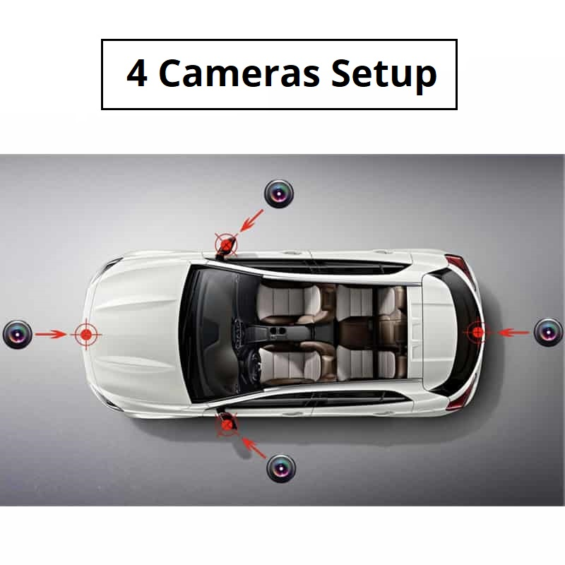

Integration of Cameras in vehicular system by using unique methodology of Camera entry Pupil point.

* 1. Seeing is believing, Cameras plays very much important role in sensing objects so it’s very much important to place camera based on viewing targets.
  2. Each supplier camera has unique pattern of entry pupil point based on the type of lenses and combination of lenses. From the target object entry ray targets are created

From camera pupil points and can generate Target field of view.

**Challenges and Objectives:**It is always a difficult to find a perfect location for camera in order to maximize the performance and meeting styling and engineering. The main objective is to provide camera NO Go surface with high confidence to see target objects without running optical simulation multiple times.

**How Product/Service Helped:**

By adopting this methodology cameras are packaged to body parts like Front Grill, Bumper, Mirror, and Tailgate area to see only targeted objects accurately.

example: Rear View Camera FMVSS Targets. And simulation results are used for confirmation only.

**Results:**

Camera initially packaged based on Pupil point entry and Camera position is confirmed from optical simulation.

